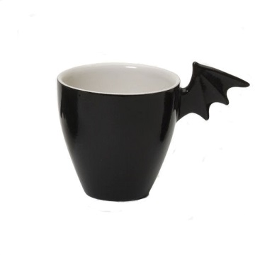

The batman style mug for younger kids...those who love the character of batman....enjoy the a cup of tea in batman mug with your friends .....

Product: MUG

Price:4,00.00 PKR

CONTACT US: Address: Aptech Metro StarGate Karachi

Phone.no: 03142191402

Email: feedback@aptech-educationcom.pk